HEALTHCARE DATA ANALYSIS AND MANAGEMENT SYSTEM

1. Abstract
The Healthcare Data Analysis and Management System is a data analytics project developed to analyze hospital operations, patient information, appointments, admissions, diagnoses, treatments, and financial transactions.
The project uses SQL Server for data storage and analysis, Python for exploratory data analysis, Excel for interactive dashboard reporting, and Power BI for advanced interactive visualization.
The objective of the project is to transform healthcare data into meaningful insights that can help understand patient demographics, hospital operations, department performance, appointment patterns, and financial performance.

2. Introduction
Healthcare organizations generate large amounts of data related to patients, doctors, appointments, admissions, diagnoses, treatments, billing, and payments.
Analyzing this information manually can make it difficult to identify important patterns and trends.
This project provides a centralized analytical solution where healthcare data is stored in a structured SQL database and analyzed using multiple data analytics tools.
The project focuses on:
- Patient analysis
- Doctor and department analysis
- Appointment analysis
- Admission analysis
- Diagnosis and treatment analysis
- Billing and payment analysis
- Revenue analysis
- Interactive dashboard reporting

3. Problem Statement
Healthcare data is often distributed across multiple operational areas such as patient registration, appointments, admissions, treatment, and billing.
Without proper analysis, it can be difficult to answer questions such as:
- How many patients are registered?
- Which departments have the most admissions?
- What is the appointment completion rate?
- Which departments generate the most revenue?
- How much payment has been received?
- How much amount is outstanding?
- Which payment methods are commonly used?
- What are the demographic characteristics of patients?
Therefore, this project aims to create a structured analytical system that converts healthcare data into useful business insights.

4. Objectives
The main objectives are:
- To create a structured healthcare database using SQL Server.
- To store patient and hospital operational information.
- To perform SQL-based data analysis.
- To perform exploratory data analysis using Python.
- To create an interactive Excel dashboard.
- To develop an interactive Power BI dashboard.
- To analyze hospital revenue and payments.
- To identify department-wise and patient-related patterns.
- To present important healthcare KPIs in an easy-to-understand format.

6. Tools and Technologies
Tool | Purpose
SQL Server | Database creation, storage and SQL analysis
Python | Exploratory Data Analysis
Pandas | Data manipulation
Matplotlib | Data visualization
Seaborn | Statistical visualization
Microsoft Excel | PivotTables, PivotCharts and dashboard
Power BI | Interactive dashboard and visualization

6. Database Design
The healthcare database consists of multiple related tables.

Main tables
- Patients
- Doctors
- Departments
- Staff
- Appointments
- Admissions
- Entry/Exit
- Diagnoses
- Treatments
- Bills
- Payments

7. SQL Analysis
SQL was used to perform data extraction, aggregation, filtering, and financial analysis.

Examples of analysis performed

Total Patients
SELECT COUNT(*) AS Total_Patients
FROM hca.patients;

Patients by Gender
SELECT gender, COUNT(*) AS Patient_Count
FROM hca.patients
GROUP BY gender;

Average Patient Age
SELECT AVG(age) AS Average_Age
FROM hca.patients;

Appointment Status
SELECT appointment_status,
COUNT(*) AS Total_Appointments
FROM hca.appointments
GROUP BY appointment_status;

Department-wise Revenue
SELECT d.department_name,
SUM(b.total_amount) AS Total_Revenue
FROM hca.bills b
JOIN hca.departments d
ON b.department_id = d.department_id
GROUP BY d.department_name;

Total Revenue
SELECT SUM(total_amount) AS Total_Revenue
FROM hca.bills;

Total Payments
SELECT SUM(payment_amount) AS Total_Payments
FROM hca.payments;

8. Python Exploratory Data Analysis
Python was used to understand the structure and distribution of the healthcare data before dashboard development.

Libraries used
import pandas as pd
import matplotlib.pyplot as plt
import seaborn as sns

Basic analysis
The following checks were performed:
- Dataset shape
- Data types
- Missing values
- Duplicate records
- Descriptive statistics
- Category distributions

Patient Analysis
Important analyses included:
- Patient distribution by gender
- Age distribution
- Blood group distribution
- City-wise patient distribution

Appointment Analysis
Three major visualizations were created:
- Appointment Status
- Appointments by Doctor
- Appointment Type Distribution

Bills Analysis
The bills table was analyzed using:
- Bill amount distribution
- Revenue trend
- Revenue by bill component

Excel Dashboard
A single-page Healthcare Data Analysis Dashboard was created in Microsoft Excel.

Dashboard KPIs
The dashboard displays:
KPI | Value
Total Patients | 50
Total Doctors | 10
Total Departments | 10
Total Appointments | 20
Total Admissions | 10
Total Revenue | ₹132,100
Outstanding Amount | ₹20,700

Dashboard visualizations
The dashboard contains:
- Patients by Gender
- Appointment Status
- Admissions by Department
- Revenue by Department
- Payment Methods
- Revenue vs Payments

Interactive slicers
Four slicers were added:
- Department Name
- Gender
- Appointment Status
- Admission Type
These allow users to filter the dashboard interactively.
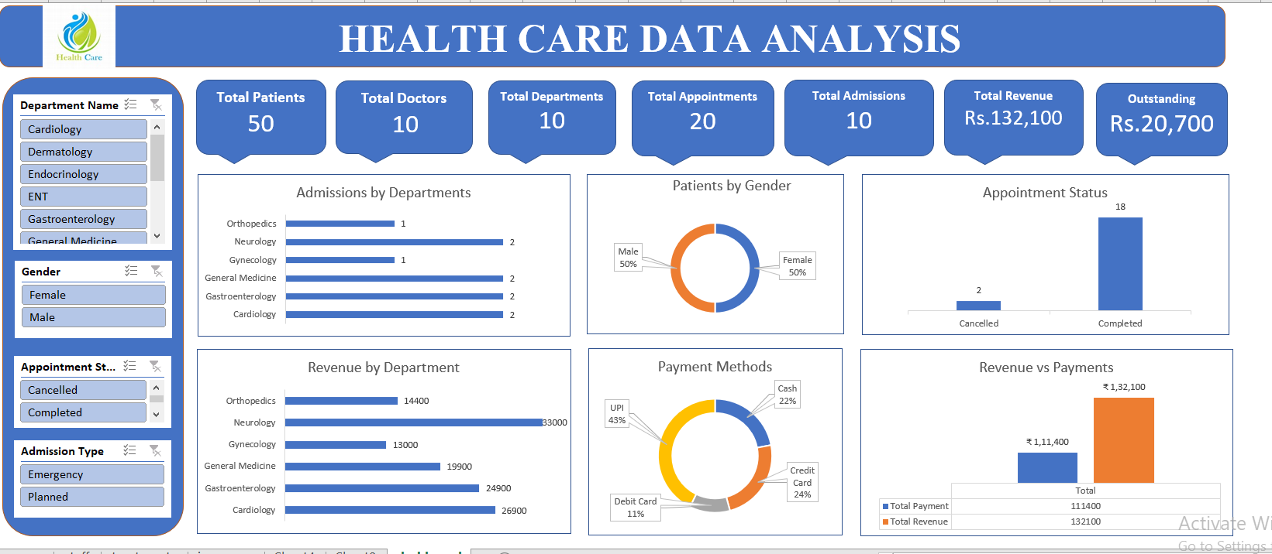

Power BI Dashboard
A multi-page Power BI dashboard was developed for more detailed analysis.

Page 1 — Healthcare Overview
KPIs:
- Total Patients
- Total Doctors
- Total Admissions
- Total Appointments
- Total Departments
- Total Revenue
Visualizations include:
- Admissions by Room Type
- Appointment Status
- Admission Type
- Diagnosis by Severity
- Admissions by Department

Page 2 — Financial Analysis
The financial dashboard focuses on hospital revenue and payment information.

KPIs
- Total Bills
- Total Revenue
- Total Payments
- Outstanding Amount
- Average Bill

Main visualizations
- Revenue by Department
- Payments by Method
- Payment Status
- Revenue Components
- Revenue Trend
- Revenue vs Payments

Page 3 — Doctor & Patient Analysis
This page analyzes patient demographics and doctor-related activity.

KPIs
- Total Patients
- Average Patient Age
- Total Diagnoses
- Total Doctors

Visualizations
- Doctor-wise Appointments
- Staff Salary by Role
- Treatment Status
- Top Diagnoses
- Patients by Gender
- Patients by Age Group

Page 4 — Insurance Analysis
The insurance page analyzes insurance companies, plans, and coverage limits.
Visualizations include:
- Patients by Insurance Company
- Patients by Insurance Plan
- Insurance Limit by Company
- Insurance Plan by Coverage Limit
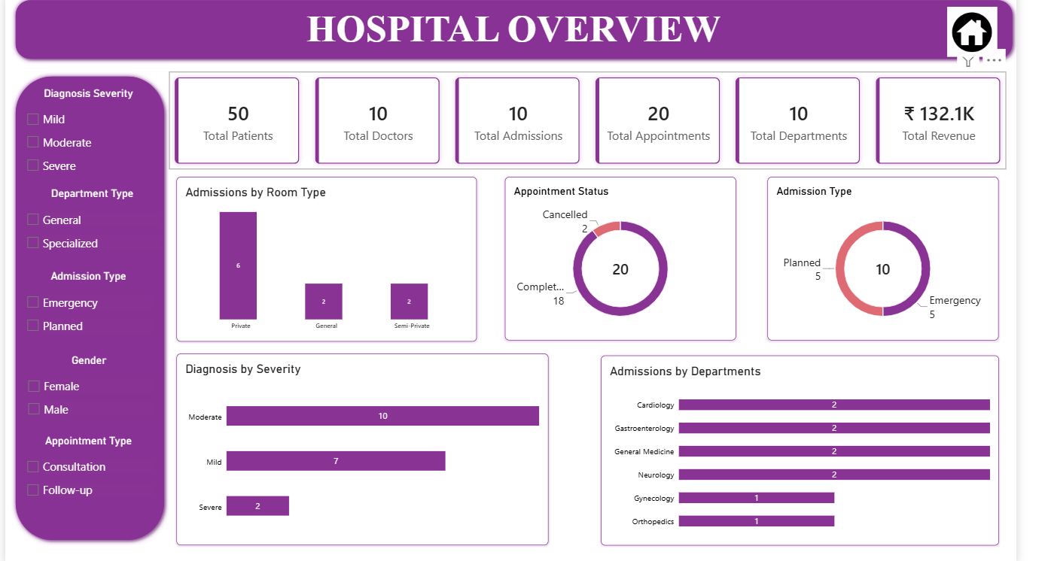

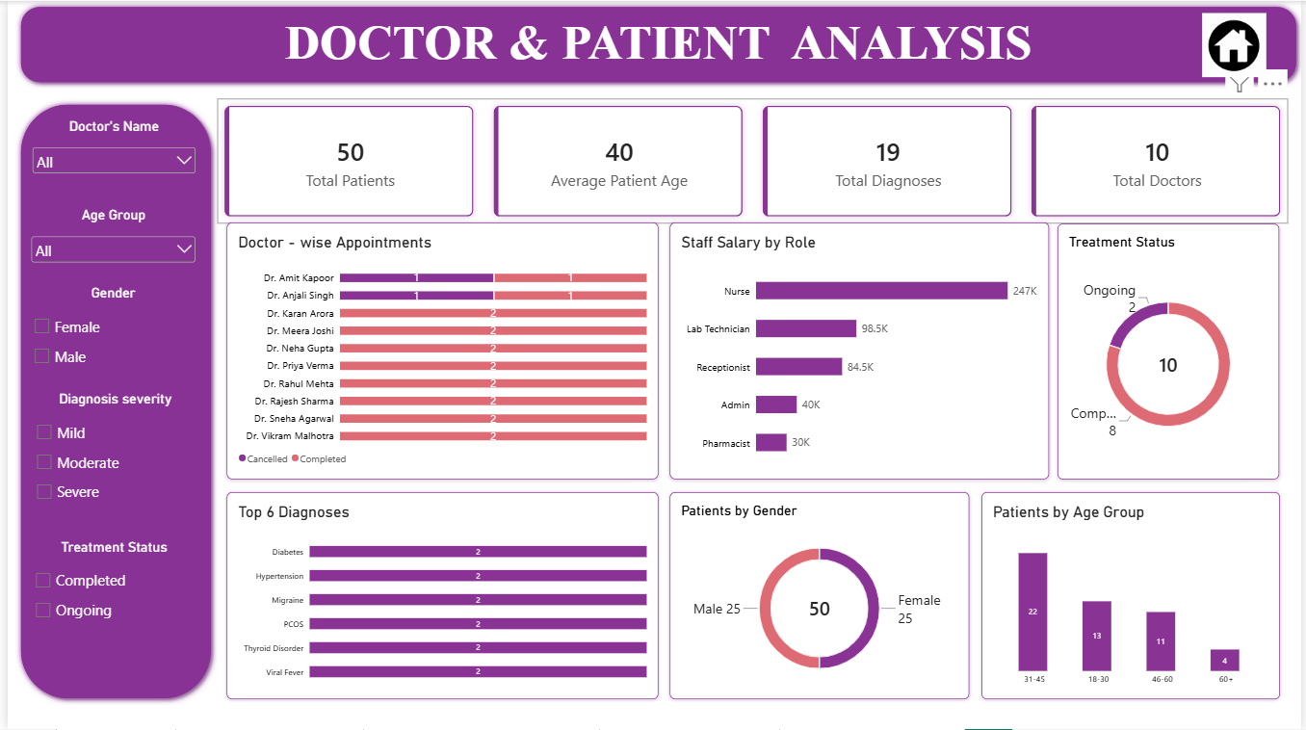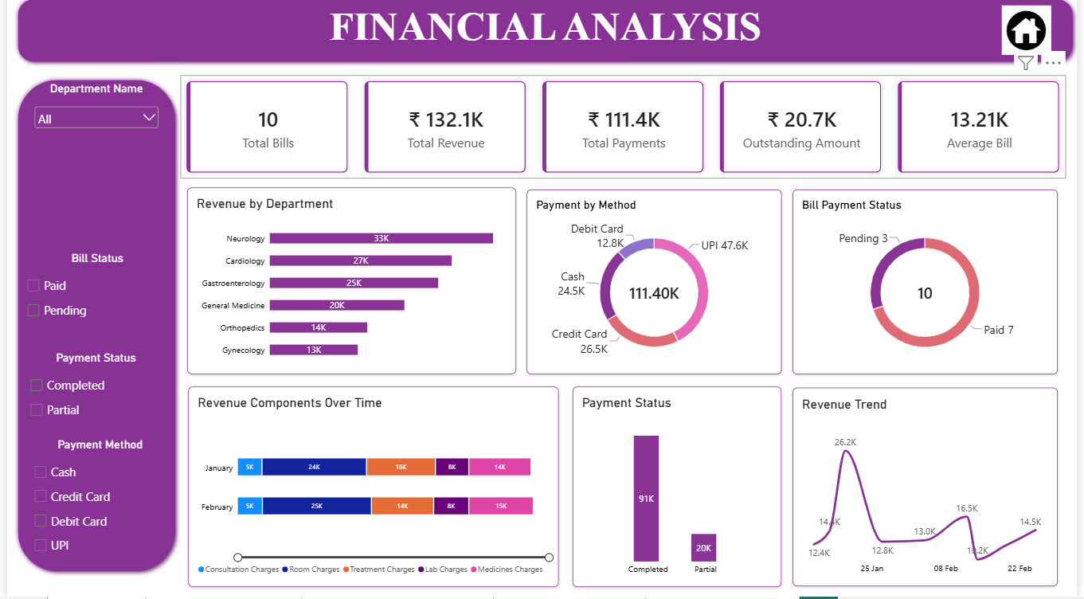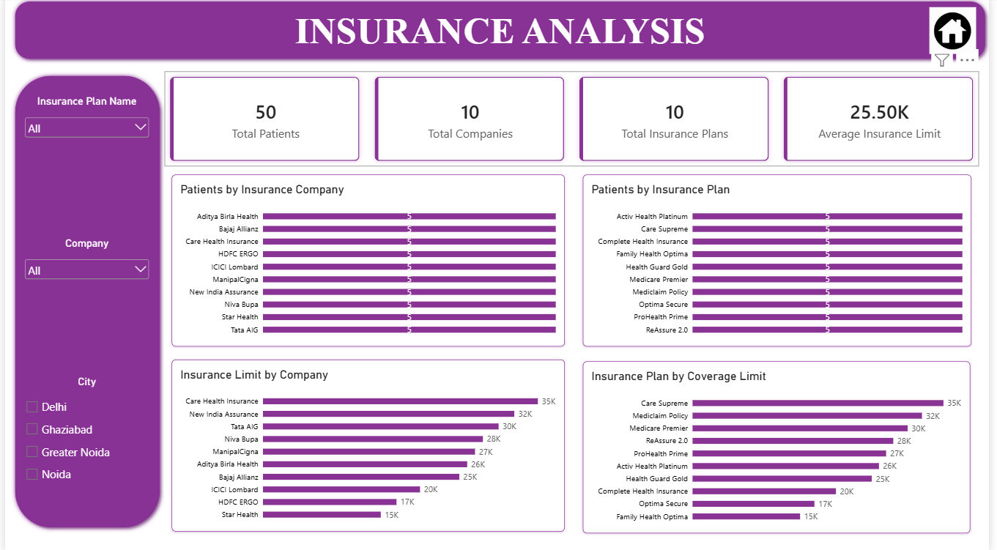

Key Findings
Based on the current dataset, the analysis provides the following observations:

Patient Overview
- The dataset contains 50 patients.
- There are 10 doctors and 10 departments.
- The patient dataset contains an equal male/female distribution in the current dashboard.

Hospital Operations
- There are 20 appointments.
- The current appointment data contains 18 completed appointments and 2 cancelled appointments.
- There are 10 admissions.

Financial Analysis
- Total billing revenue is ₹132,100.
- Total payments received are ₹111,400.
- The calculated outstanding amount is ₹20,700.
- Average bill value is approximately ₹13,210.

Department Analysis
Department-level analysis shows differences in admission counts and revenue generation, allowing hospital management to compare operational and financial activity across departments.

